# Exercises: Single Page Apps with AJAX, REST and Kinvey

Problems for exercise at the [“JavaScript Applications” course @ SoftUni](https://softuni.bg/courses/javascript-applications). Submit your solution in the SoftUni [instance](https://softuni.bg/trainings/1505/js-applications-november-2016) as homework. You can use this [presentation](https://softuni.bg/downloads/svn/js-core/Sept-2016/JS-Apps-Nov-2016/7.%20JS-Apps-SPA-with-AJAX-REST-Kinvey/7.%20JS-Apps-SPA-with-AJAX-REST-Kinvey.pptx) to help you throughout this exercise.

## Prodavachnik

Your task is to implement a Web page that serves the functionally of an **advertisement** **site**, which specializes in **selling** **products**/**services**. The API will consist of creating, listing, editing and deleting of **advertisements**(**CRUD**). Every **advert** should contain the following properties:

* Title - String
* Description - String
* Publisher - String
* Date of Publishing – Date (format “**mm/dd/yyyy**”)
* Price – **floating** point number, to the **second** **digit** after decimal separator.

You can download the skeleton (HTML and CSS) [here](https://softuni.bg/downloads/svn/js-core/May-2017/JS-Apps-Jun-2017/8.%20JS-Apps-Single-Page-Applications-Exercises/Prodavachnik%20-%20Skeleton.zip).

### Screenshots

Home page:

Registration page (Login page is identical):

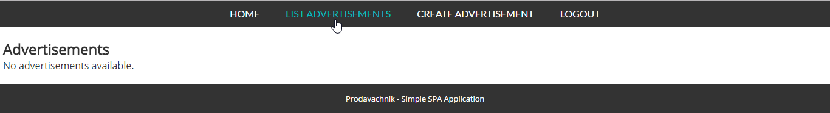This is how the website should look like when there are no adverts:

Let’s create one (the view for editing an advert is identical):

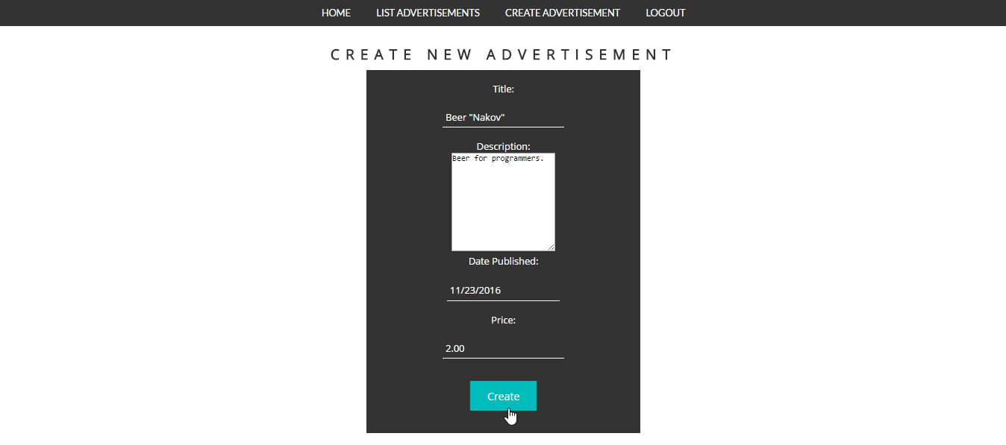

And this is how it should be listed:



The advertisement site should have the following functionality:

* Perform any **CRUD** operations over the advertisement entity.
  + Note that the **publisher** of the advertisement is the **currently** logged **user**.
  + Publisher can edit/delete his own adverts only.
* Have **Register**/**Login**/**Logout**.

### Hints

* 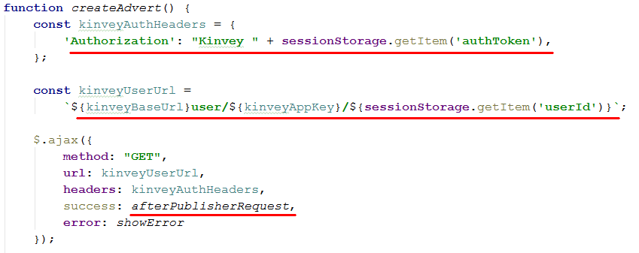When **create** an **advertisement** the current logged user should be it’s **publisher**. We can do it by making one request to the database (by user’s **“_id”** property) and retrieve the whole **user** information. It may look something like that:

Once we got the user information we can use it in our “afterPublisherRequest” method:

And the rest is **parsing** the **information** from the form and sending **another** **request** – this time to **save** our **advert** in database.

**Note** that the above method should be called when the form for **advert** **creation** is **submitted**.

* When **editing** an advert in which we don’t want to change the **publisher** you can include it in the html, but mark it as “hidden”, here is how the html might look:

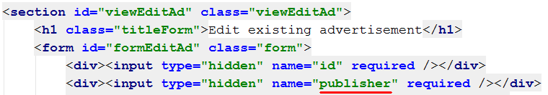

What is left is to **initially** **set** the **value** when printing the edit form **and** then **parsing** the whole **data** when the form is **submitted**.

## Extend “Prodavachnik” (Optional)

Your task is to extend the functionality of the above project (when completed).

What have to be done is:

1. Creating **one** **more** **view**(“section”), which will be used to **display** one **single** **advertisement**. The view should be accessible when you list all advertisements (by creating another **link** – “**Read more**” e.g.).
2. **Add** another **property** to the advertisements which should be **integer** – the **count** of **views** for every advert. Every advert should have **0** views **initially**. And that count will **grow** when someone tries to **display** its **single** view (when the “Read more” link is clicked).
3. Add also another **string** property containing **link** to some **image** (image will be used to display more information about current advert).
4. Whenever you list all the adverts, **sort** them **by** **views** count descending.

For more clarity check the screenshots below.

### Screenshots

We should extend the create advert functionality. Now we should have **image** field:

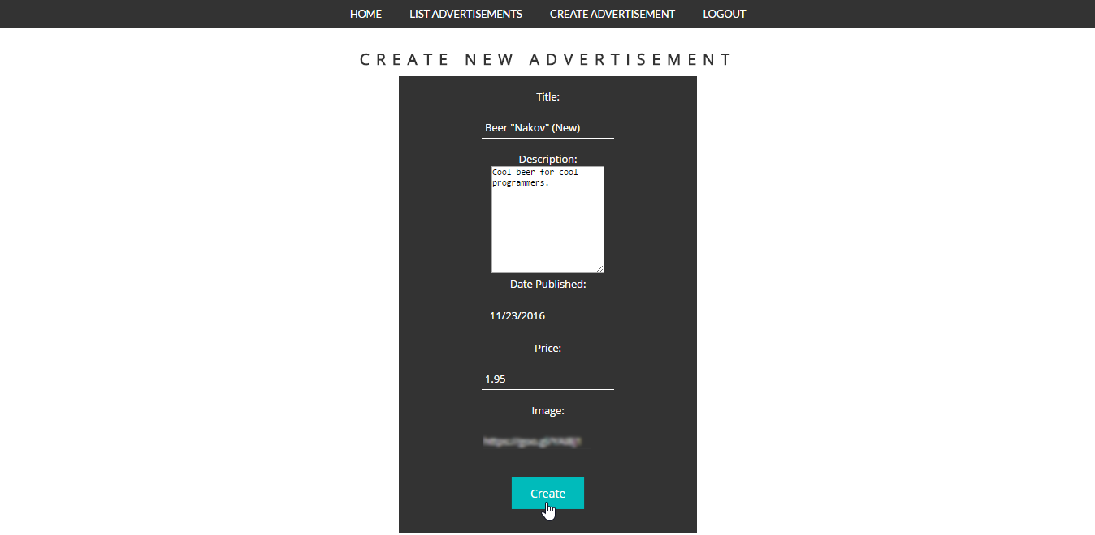

And when all adverts are listed: new “Read more” link:



Cool. Let’s check the “**Read more**” out:

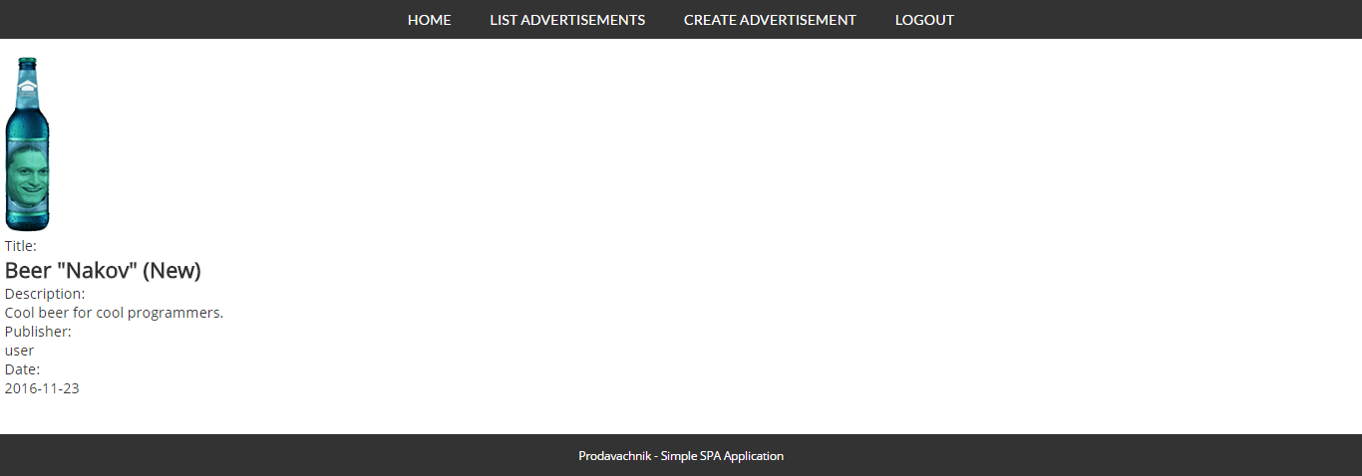

Here we have our **detailed** **view** about particular advert. What we have in addition to the previous one is that we have a **photo** and a **views** counter.

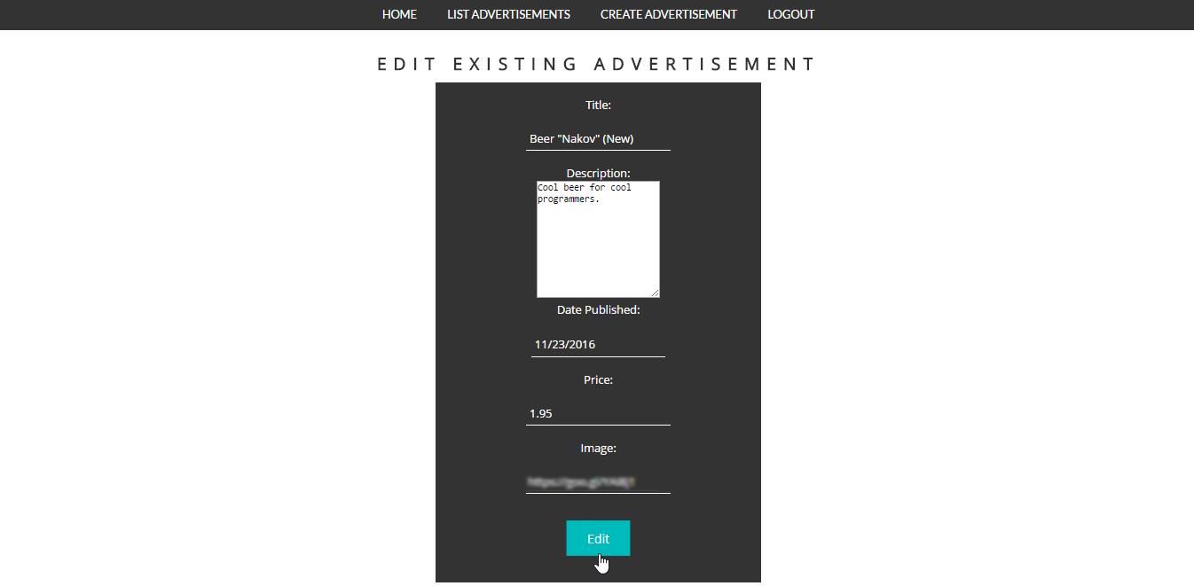We should be able to **change** the **image** later on (if we want to):

### Hints

* For the details view you can just add another section and give it some id, so you can later on refer it.
* Then on the part where **listing** of adverts is done, just add another action(<a> tag) – next to **delete** and **edit**:

**Create** the “Read more” **link** and attach action:

Add it to all links:



* 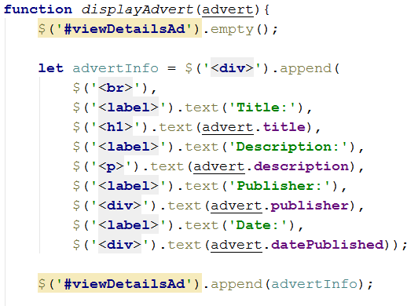The action should **render** some **html** – nothing special: some html tags with some content in it. Here is an **example** of how it might look like:

**\*Remember** later on when you add the new properties to include them here as well.

* Editing an advert should now also change the **image** url for the advert.

Note that the variables’ names might differ from the ones in your project.

**function** *startApp*() {  
  
 *setGreeting*();  
 **$**(**'#viewHome'**).show()  
 **const** baseUrl = **'https://baas.kinvey.com/'**;  
 **const** appKey = **'kid_Hy2tfArw-'**;  
 **const** appSecret = **'87af4f6be3d54465ad901394061f1c1c'**;  
  
 **$**(**'#linkHome'**).**click**(() => *showView*(**'home'**));  
 **$**(**'#linkLogin'**).**click**(() => *showView*(**'login'**));  
 **$**(**'#linkRegister'**).**click**(() => *showView*(**'register'**));  
 **$**(**'#linkListAds'**).**click**(() => *showView*(**'ads'**));  
 **$**(**'#linkCreateAd'**).**click**(() => *showView*(**'create'**));  
 **$**(**'#linkLogout'**).**click**(*logout*);  
  
 **$**(**document**).on({  
 ajaxStart: () => **$**(**'#loadingBox'**).show(),  
 ajaxStop: () => **$**(**'#loadingBox'**).hide()  
 });  
  
 **$**(**'#infoBox'**).**click**((event) => **$**(event.**target**).hide());  
 **$**(**'#errorBox'**).**click**((event) => **$**(event.**target**).hide());  
  
  
 **$**(**'#buttonLoginUser'**).**click**(*login*);  
 **$**(**'#buttonRegisterUser'**).**click**(*register*);  
 **$**(**'#buttonCreateAd'**).**click**(*createAd*);  
  
  
 **function** *showInfo*(message) {  
 **$**(**'#infoBox'**).**text**(message);  
 **$**(**'#infoBox'**).show();  
 setTimeout(() => **$**(**'#infoBox'**).**fadeOut**(), 3000);  
 };  
  
 **function** *showError*(message) {  
 **$**(**'#errorBox'**).**text**(message);  
 **$**(**'#errorBox'**).show();  
 };  
  
 **function** *showView*(view) {  
 **$**(**'section'**).hide();  
 **switch** (view){  
 **case 'home'**: **$**(**'#viewHome'**).show(); **break**;  
 **case 'login'**: **$**(**'#viewLogin'**).show(); **break**;  
 **case 'register'**: **$**(**'#viewRegister'**).show(); **break**;  
 **case 'ads'**:  
 *loadAds*();  
 **$**(**'#viewAds'**).show(); **break**;  
 **case 'create'**: **$**(**'#viewCreateAd'**).show(); **break**;  
 **case 'edit'**: **$**(**'#viewEditAd'**).show(); **break**;  
 **case 'readMore'**: **$**(**'#readMore'**).show(); **break**;  
  
 }  
 }  
  
 **function** *handleError*(err) {  
 *showError*(err.responseJSON.**description**)  
 };  
  
 **function** *login*() {  
 **let** form = **$**(**'#formLogin'**);  
 **let** username = form.**find**(**'input[name="username"]'**).val();  
 **let** password = form.**find**(**'input[name="passwd"]'**).val();  
  
 **$**.**ajax**({  
 **url**: baseUrl + **'user/'** + appKey + **'/login'**,  
 **method**: **"POST"**,  
 **headers**: {  
 **'Authorization'**: **'Basic '** + btoa(appKey + **":"** + appSecret),  
 **'Content-Type'**: **'application/json'** },  
 **data**: ***JSON***.stringify({  
 **username**: username,  
 **password**: password  
 }),  
 success: *loginSuccess*,  
 **error**: *handleError* });  
  
 **function** *loginSuccess*(data) {  
 *showInfo*(**'Login successful'**);  
 **localStorage**.setItem(**'username'**, data.**username**);  
 **localStorage**.setItem(**'id'**, data._id);  
 **localStorage**.setItem(**'authtoken'**, data._kmd.authtoken);  
 *setGreeting*();  
 *showView*(**'home'**);  
 }  
 }  
  
 **function** *register*() {  
 **let** form = **$**(**'#formRegister'**);  
 **let** username = form.**find**(**'input[name="username"]'**).val();  
 **let** password = form.**find**(**'input[name="passwd"]'**).val();  
  
 **$**.**ajax**({  
 **url**: baseUrl + **'user/'** + appKey,  
 **method**: **"POST"**,  
 **headers**: {  
 **'Authorization'**: **'Basic '** + btoa(appKey + **":"** + appSecret),  
 **'Content-Type'**: **'application/json'** },  
 **data**: ***JSON***.stringify({  
 **username**: username,  
 **password**: password  
 }),  
 success: *registerSuccess*,  
 **error**: *handleError* });  
  
 **function** *registerSuccess*(data) {  
 *showInfo*(**'Registration successful'**);  
 **localStorage**.setItem(**'username'**, data.**username**);  
 **localStorage**.setItem(**'id'**, data._id);  
 **localStorage**.setItem(**'authtoken'**, data._kmd.authtoken);  
 *setGreeting*();  
 *showView*(**'home'**);  
 }  
  
 }  
  
 **function** *setGreeting*() {  
 **let** username = **localStorage**.getItem(**'username'**);  
 **if**(username !== **null**){  
 **$**(**'#loggedInUser'**).**text**(**`Welcome,** ${username}**!`**)  
 **$**(**'#linkHome'**).show();  
 **$**(**'#linkLogin'**).hide();  
 **$**(**'#linkRegister'**).hide();  
 **$**(**'#linkCreateAd'**).show();  
 **$**(**'#linkListAds'**).show();  
 **$**(**'#linkLogout'**).show();  
 **$**(**'#loggedInUser'**).show();  
 }  
 **else** {  
 **$**(**'#loggedInUser'**).**text**(**''**);  
 **$**(**'#linkHome'**).show();  
 **$**(**'#linkLogin'**).show();  
 **$**(**'#linkRegister'**).show();  
 **$**(**'#linkLogout'**).hide();  
 **$**(**'#linkCreateAd'**).hide();  
 **$**(**'#linkListAds'**).hide();  
 **$**(**'#loggedInUser'**).show();  
 }  
  
 }  
  
 **function** *logout*() {  
 **$**.**ajax**({  
 **url**: baseUrl + **'user/'** + appKey + **'/_logout'**,  
 **method**: **"POST"**,  
 **headers**: {  
 **'Authorization'**: **'Kinvey '** + **localStorage**.getItem(**'authtoken'**),  
 },  
 **success**: *logoutSuccess*(),  
 **error**: *handleError* });  
  
 **function** *logoutSuccess*(data) {  
 **localStorage**.clear();  
 *setGreeting*();  
 *showView*(**'home'**);  
 }  
  
 }  
  
 **function** *loadAds*() {  
 **$**.**ajax**({  
 **url**: baseUrl + **"appdata/"** + appKey + **"/reklami"**,  
 **method**: **"GET"**,  
 **headers**: {  
 **'Authorization'**: **'Kinvey '** + **localStorage**.getItem(**'authtoken'**),  
 **'Content-Type'**: **'application/json'** },  
 success: *displayAds*,  
 **error**: *handleError* });  
  
 **function** *displayAds*(data) {  
 **let** form = **$**(**'#viewAds'**).**find**(**'#ads'**).**find**(**'table'**).**find**(**'tbody'**).**find**(**'tr'**);  
 form.empty();  
  
 **for** (**let** element **of** data) {  
 **let** tr = **$**(**'<tr>'**);  
 tr.append(**`<td>**${element.**title**}**</td>`**);  
 tr.append(**`<td>**${element.**publisher**}**</td>`**);  
 tr.append(**`<td>**${element.**description**}**</td>`**);  
 tr.append(**`<td>**${element.**price**}**</td>`**);  
 tr.append(**`<td>**${element.imageUrl}**</td>`**);  
 tr.append(**`<td>**${element[**'DatePublished'**]}**</td>`**);  
 **let** td = **$**(**'<td>'**);  
 **let** readMore = **$**(**'<a href="#">[Read More]</a>'**).**click**(() => *readMoreAd*(element));  
 **let** empty = **' '**;  
 td.append(readMore).append(empty);  
  
 **if**(element.**publisher** === **localStorage**.getItem(**'username'**)){  
 **let** del = **$**(**'<a href="#">[Delete]</a>'**).**click**(() => *deleteAd*(element._id));  
 **let** empty = **' '**;  
 **let** edit = **$**(**'<a href="#">[Edit]</a>'**).**click**(() => *openUpdateAd*(element));  
 td.append(del).append(empty).append(edit);  
  
 }  
  
 tr.append(td);  
 tr.**appendTo**(**$**(**'#viewAds'**).**find**(**'table'**).**find**(**'tbody'**));  
  
 };  
 }  
 }  
  
 **function** *createAd*() {  
 **let** titleInput = **$**(**'#formCreateAd'**).**find**(**"[name='title']"**).val();  
 **let** descriptionInput =**$**(**'#formCreateAd'**).**find**(**"[name='description']"**).val();  
 **let** dateInput = **$**(**'#formCreateAd'**).**find**(**"[name='datePublished']"**).val();  
 **let** priceInput = **$**(**'#formCreateAd'**).**find**(**"[name='price']"**).val();  
 **let** imageInput = **$**(**'#formCreateAd'**).**find**(**"[name='image']"**).val();  
  
 **if**(titleInput.**length** === 0 ){  
 *showError*(**'Title cannot be empty'**);  
 **return**;  
 };  
  
 **if**(descriptionInput.**length** === 0){  
 *showError*(**'Description cannot be empty'**);  
 **return**;  
 };  
  
 **if**(imageInput.**length** === 0){  
 *showError*(**'Image Url cannot be empty'**);  
 **return**;  
 };  
  
 **if**(priceInput === **''**){  
 *showError*(**'Price cannot be empty'**);  
 **return**;  
 };  
  
 **if**(dateInput === **''** ){  
 *showError*(**'Date cannot be empty'**);  
 **return**;  
 };  
  
 **let** ad = {  
 **title**: titleInput,  
 **description**: descriptionInput,  
 **publisher**: **localStorage**.getItem(**'username'**),  
 **DatePublished**: dateInput.toString(**'yyyy-dd-MM'**),  
 **imageUrl**: imageInput,  
 **price**: priceInput  
 };  
  
 **$**.**ajax**({  
 **url**: baseUrl + **"appdata/"** + appKey + **"/reklami"**,  
 **method**: **"POST"**,  
 **headers**: {  
 **'Authorization'**: **'Kinvey '** + **localStorage**.getItem(**'authtoken'**),  
 **'Content-Type'**: **'application/json'** },  
 **data**: ***JSON***.stringify(ad),  
 **success**: (() => {  
 *showInfo*(**'Ad created'**),  
 *showView*(**'ads'**)  
 }),  
 **error**: *handleError* });  
 }  
  
 **function** *deleteAd*(id) {  
 **$**.**ajax**({  
 **url**: baseUrl + **"appdata/"** + appKey + **'/reklami/'** + id,  
 **method**: **"DELETE"**,  
 **headers**: {  
 **"Authorization"**: **"Kinvey "** + **localStorage**.getItem(**'authtoken'**),  
 **'Content-Type'**: **'application/json'** },  
 **success**: (() => {  
 *loadAds*(),  
 *showInfo*(**'Ad deleted'**)  
 }),  
 **error**: *handleError* })  
 };  
  
 **function** *openUpdateAd*(element) {  
 **let** form = **$**(**"#formEditAd"**);  
 form.**find**(**'input[name="title"]'**).val(element.**title**);  
 form.**find**(**'textarea[name="description"]'**).val(element.**description**);  
 form.**find**(**'input[name="price"]'**).val(element.**price**);  
 form.**find**(**'input[name="image"]'**).val(element.imageUrl);  
  
  
 **let** date = element.**DatePublished**;  
 **let** publisher = element.**publisher**;  
 **let** id = element._id;  
  
 **$**(**'#buttonEditAd'**).**click**(() => *updateAd*(date, publisher, id));  
  
 *showView*(**'edit'**);  
 }  
  
 **function** *updateAd*(date, publisher, id) {  
 **let** form = **$**(**"#formEditAd"**);  
 **let** title = form.**find**(**'input[name="title"]'**).val();  
 **let** description = form.**find**(**'textarea[name="description"]'**).val();  
 **let** price = form.**find**(**'input[name="price"]'**).val();  
 **let** image = form.**find**(**'input[name="image"]'**).val();  
  
  
 **if**(title.**length** === 0 ){  
 *showError*(**'Title cannot be empty'**);  
 **return**;  
 };  
  
 **if**(description.**length** === 0){  
 *showError*(**'Description cannot be empty'**);  
 **return**;  
 };  
  
 **if**(image.**length** === 0){  
 *showError*(**'Image Url cannot be empty'**);  
 **return**;  
 };  
  
 **if**(price === **''**){  
 *showError*(**'Price cannot be empty'**);  
 **return**;  
 };  
  
 **$**.**ajax**({  
 **method**: **"PUT"**,  
 **url**: baseUrl + **"appdata/"** + appKey + **"/reklami/"** + id,  
 **headers**: {  
 **"Authorization"**: **"Kinvey "** + **localStorage**.getItem(**'authtoken'**)  
 },  
 **contentType**: **"application/json"**,  
 **data**: ***JSON***.stringify({  
 title,  
 description,  
 publisher,  
 **imageUrl**: image,  
 **DatePublished**: date,  
 price  
 }),  
 **success**: (() => {  
 *showInfo*(**'Ad updated!'**),  
 *showView*(**'ads'**)  
 }),  
 **error**: *handleError* })  
 }  
  
 **function** *readMoreAd*(element) {  
 **let** div = **$**(**'#readMoreDiv'**);  
 div.empty();  
  
 div.append(**`<img id="img" src="**${element.imageUrl}**">`**);  
 div.append(**'<br>'**);  
 div.append(**'<label><strong>Title:</strong></label>'**);  
 div.append(**`<p>**${element.**title**}**</p>`**);  
 div.append(**'<label><strong>Description:</strong></label>'**);  
 div.append(**`<p>**${element.**description**}**</p>`**);  
 div.append(**'<label><strong>Publisher:</strong></label>'**);  
 div.append(**`<p>**${element.**publisher**}**</p>`**);  
 div.append(**'<label><strong>Date:</strong></label>'**);  
 div.append(**`<p>**${element.**DatePublished**}**</p>`**);  
  
  
 *showView*(**'readMore'**);  
 }  
  
}

## ***Add Viewcounter

Your task is to extend the functionality of the above project (when completed):

1. **Add** another **property** to the advertisements which should be **integer** – the **count** of **views** for every advert. Every advert should have **0** views **initially**. And that count will **grow** when someone tries to **display** its **single** view (when the “Read more” link is clicked).
2. Whenever you list all the adverts, **sort** them by **views** **count,** descending.

For more clarity check the screenshots below.

### Screenshots

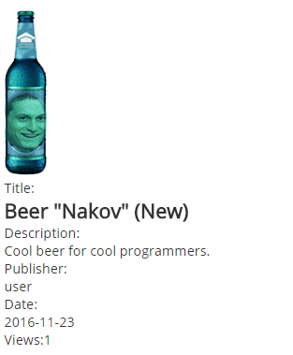

### Hints

Implementing this functionality requires writing some business logic for your Kinvey app – since only the person who created an ad can modify it in the database, you can’t just keep the views in the same object and update it when requested. Research [business logic](http://devcenter.kinvey.com/rest/guides/business-logic) and [collection access](http://devcenter.kinvey.com/rest/reference/business-logic/reference.html#collection-access-module) in Kinvey docs.